Task 1
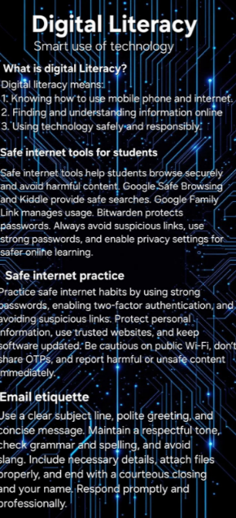

In Task 1, I created a digital literacy infographic using Canva. The main aim of this task was to spread awareness about the importance of digital literacy among students. In the infographic, I included key topics such as the meaning of digital literacy, useful digital tools for students, safe internet practices, professional online presence, and email etiquette.
I designed the infographic in a simple and visually appealing way so that it is easy to understand. I used different colors, icons, and short bullet points to present the information clearly. This helped in making the content more attractive and engaging for viewers. Instead of writing long paragraphs, I focused on highlighting important points in a concise format.
While working on this task, I found it interesting to use Canva and explore its features. However, selecting the right layout and organizing the content properly was slightly challenging in the beginning. Overall, this task helped me improve my creativity and taught me how to present information effectively using digital tools.

